**Query ZODATA_OR_Q1_CDC_CDP_AWS_V2**

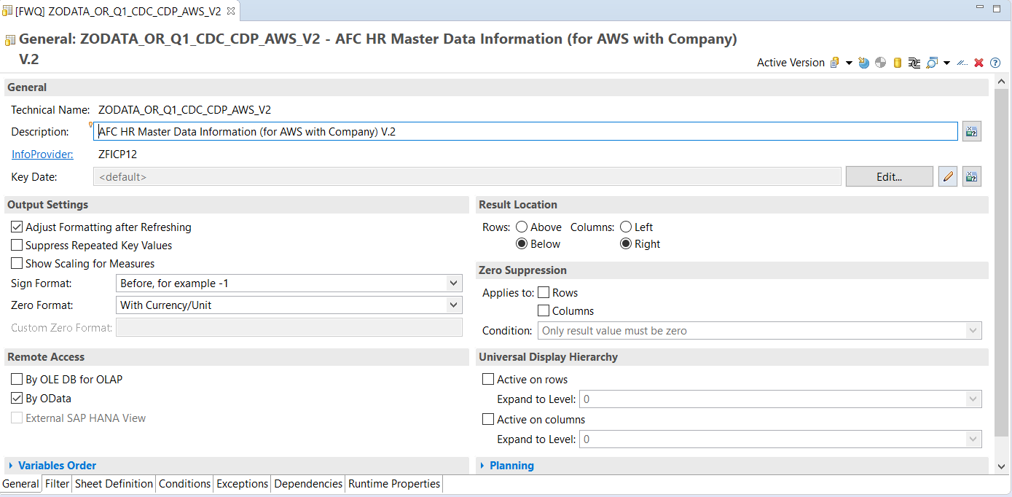

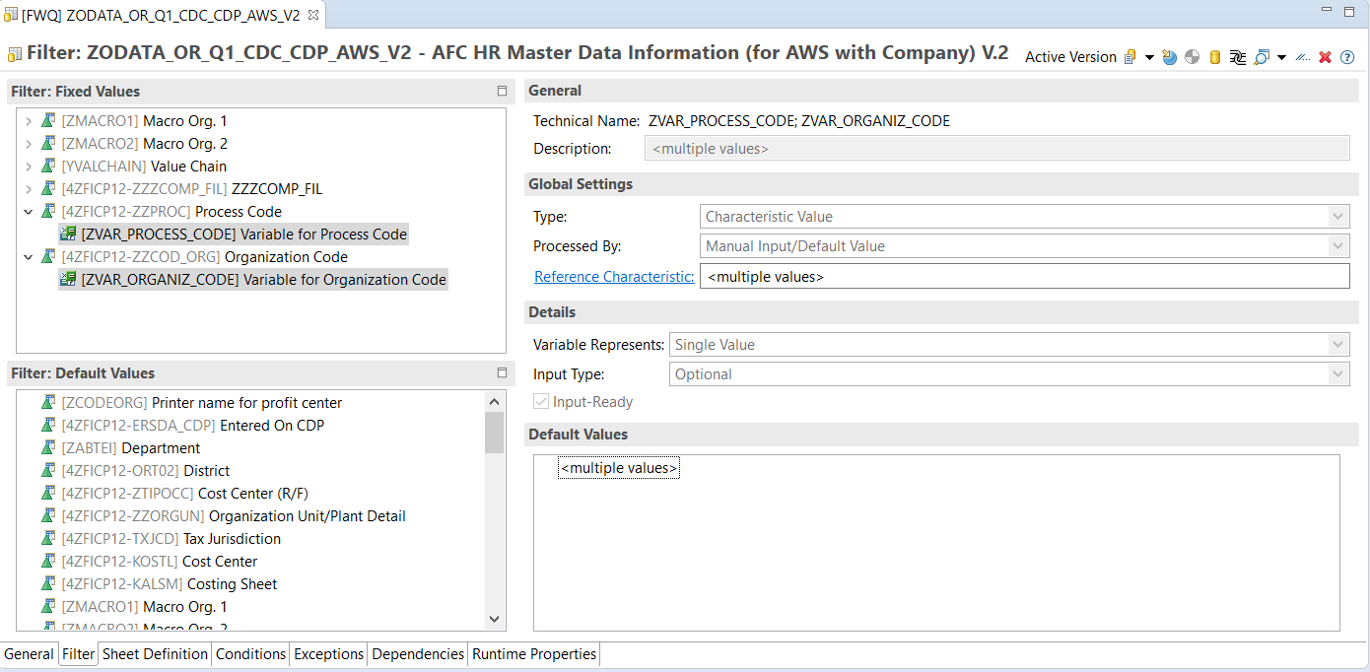

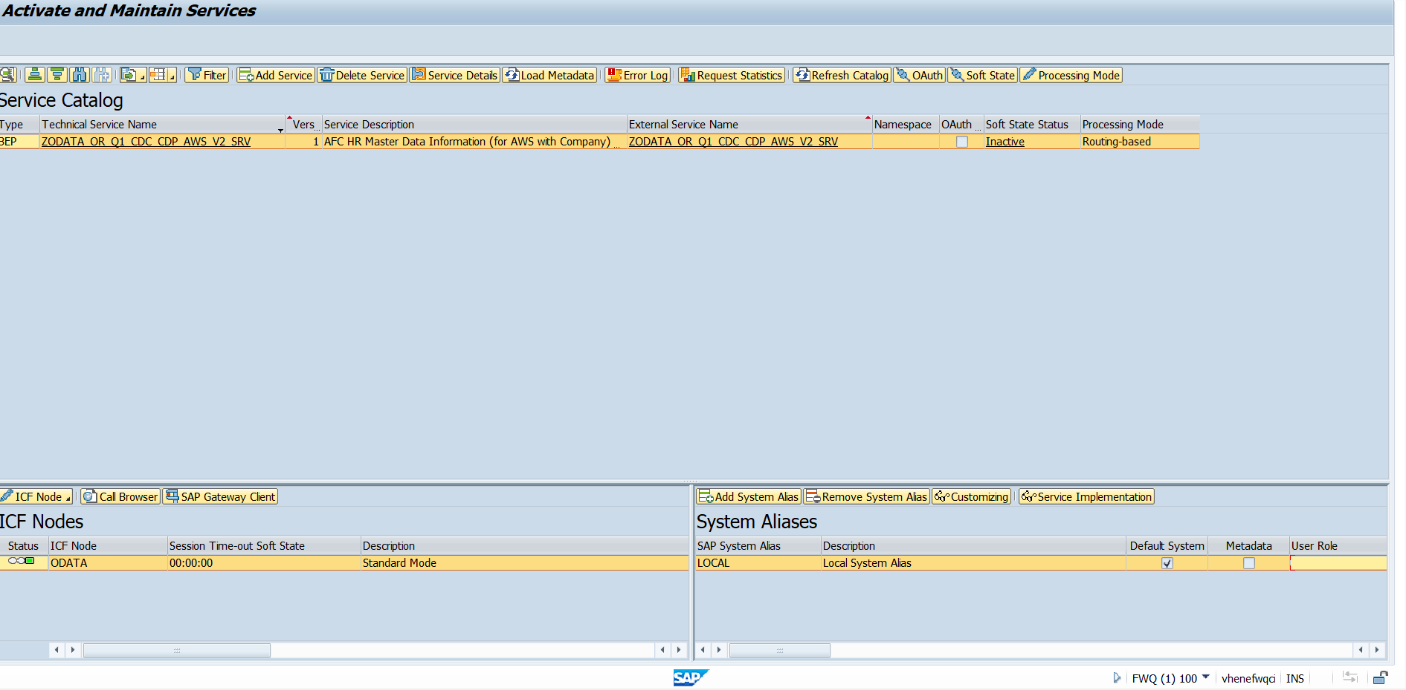

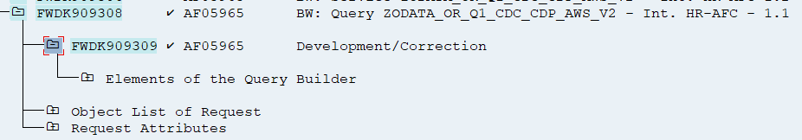

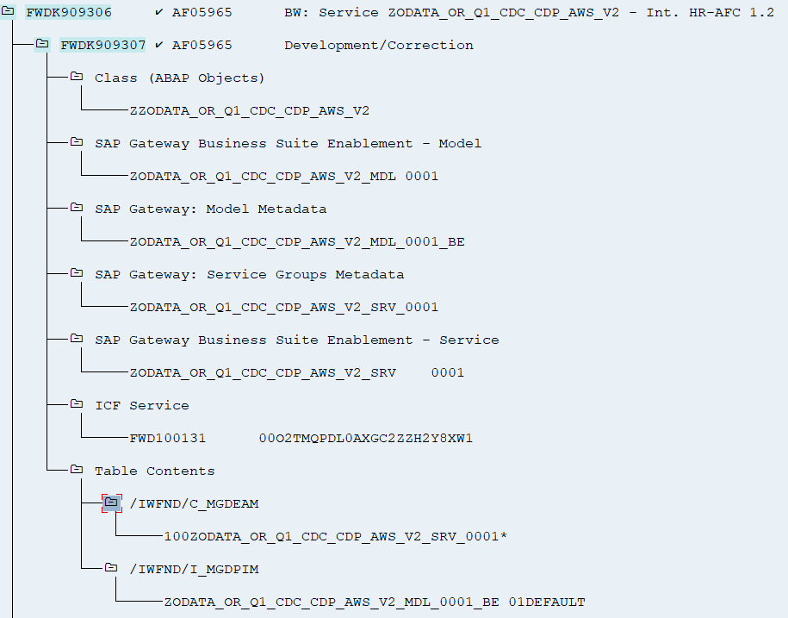

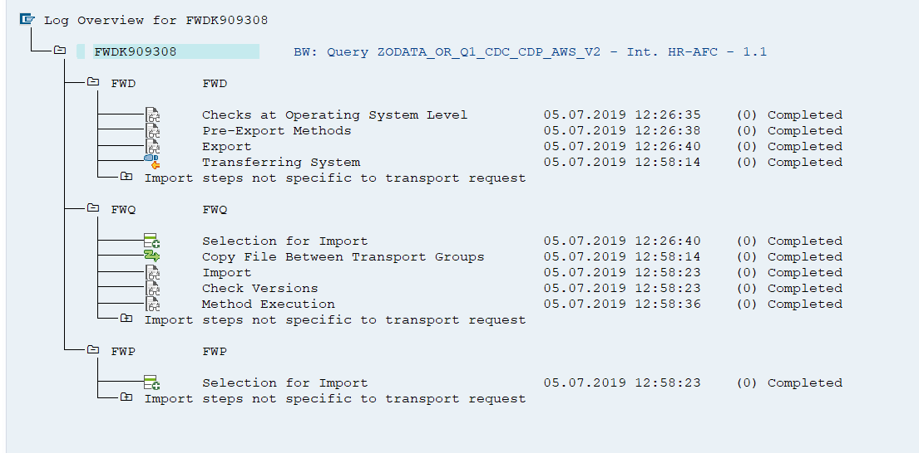

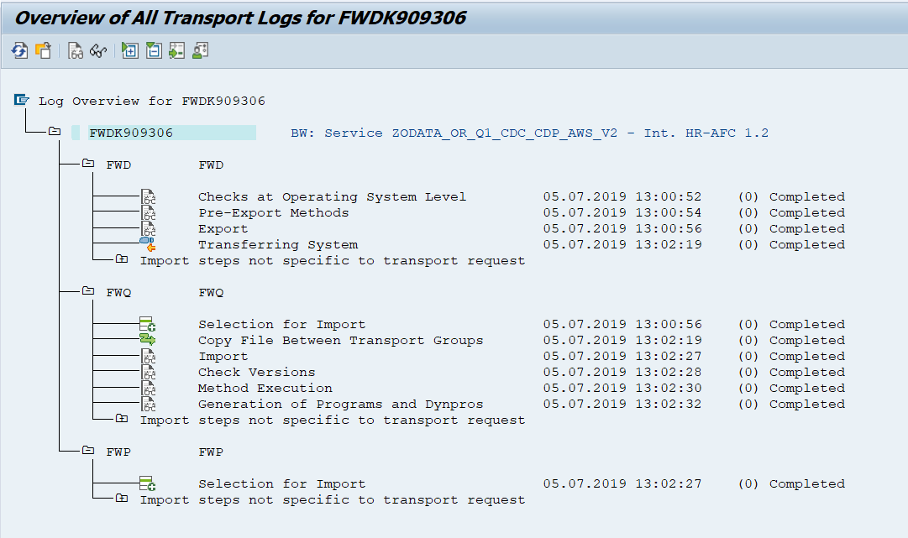

**Test in FWQ:**

**Estrazione completa:**



**Link Old:**

https://fwqwd.hec.enelint.global:44380/sap/opu/odata/sap/ZODATA_OR_Q1_CDC_CDP_AWS_SRV/ZODATA_OR_Q1_CDC_CDP_AWS(ZVAR_MACRO_ORG1='BSER',ZVAR_MACRO_ORG2='ACTSEST05',ZVAR_VCS='VCS0003',ZVAR_COMPANY_FILTER='IT1C')/Results/?saml2=disabled&$format=json



**Link New:**

https://fwqwd.hec.enelint.global:44380/sap/opu/odata/sap/ZODATA_OR_Q1_CDC_CDP_AWS_V2_SRV/ZODATA_OR_Q1_CDC_CDP_AWS_V2(ZVAR_MACRO_ORG1='BSER',ZVAR_MACRO_ORG2='ACTSEST05',ZVAR_VCS='VCS0003',ZVAR_COMPANY_FILTER='IT1C',ZVAR_PROCESS_CODE='',ZVAR_ORGANIZ_CODE='')/Results/?saml2=disabled&$format= json



**Link New + Test nuovi filtri**

https://fwqwd.hec.enelint.global:44380/sap/opu/odata/sap/ZODATA_OR_Q1_CDC_CDP_AWS_V2_SRV/ZODATA_OR_Q1_CDC_CDP_AWS_V2(ZVAR_MACRO_ORG1='',ZVAR_MACRO_ORG2='',ZVAR_VCS='',ZVAR_COMPANY_FILTER='',ZVAR_PROCESS_CODE='DOTP',ZVAR_ORGANIZ_CODE='CD11')/Results/?saml2=disabled&$format= json

